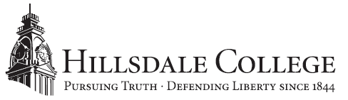

FOR IMMEDIATE RELEASE CONTACTS: Emily Stack Davis Matthew Kagel
March 16, 2017 517-607-2730 (work) 703-297-4898
517-803-3745 (cell) kagel@pinkstongroup.com
PR@hillsdale.edu

Ryan Walsh, ’09, on 2017 Forbes List for ‘30 Under 30’

Hillsdale, Mich. — Hillsdale College congratulates alumnus Ryan Walsh,’09, for being named to the 2017 Forbes 30 Under 30: Law & Policy list. Walsh joins 600 select individuals across 20 industries recognized on the prestigious Forbes lists, during what the magazine called “the most extreme competition ever.”

“Ryan was an exceptional student here at Hillsdale. He exemplifies the good character and sound principles the College stands for,” said Nathan Schlueter, professor of philosophy and director of the pre-law program, who served as an academic mentor for Walsh. “A real classical liberal arts education, rooted in a study of the great books, is an excellent preparation for the legal profession. Ryan’s success shows that.”

Walsh currently serves as the chief deputy solicitor general for the state of Wisconsin. He was previously an associate attorney at the elite law firm Jones Day where he focused on administrative and constitutional law. He clerked for the late Supreme Court Justice Antonin Scalia and the Ninth Circuit of the U.S. Court of Appeals.

Walsh was class president during his senior year at Hillsdale College and graduated summa cum laude with a Bachelor of Arts in American Studies. He earned his J.D. at the University of Chicago Law School with high honors and was named a John Marshall Fellow of the Claremont Institute for the Study of Statesmanship and Political Philosophy.

The 2017 Forbes “30 Under 30” list recognizes just 600 individuals from among 15,000 nominations, which constitutes a 4 percent acceptance rate that is lower than the nation’s two most selective colleges, Stanford University (4.8 percent) and Harvard University (5.2 percent), according to Forbes’ website.

Walsh’s full profile in the Forbes “30 Under 30” list can be found here.

About Hillsdale College
Hillsdale College, founded in 1844, has built a national reputation through its classical liberal arts core curriculum and its principled refusal to accept federal or state taxpayer subsidies, even indirectly in the form of student grants or loans. It also conducts an educational outreach effort promoting civil and religious liberty, including a free monthly speech digest, Imprimis, with a circulation of more than 3.5 million. More information available at Hillsdale.edu.
# # #

