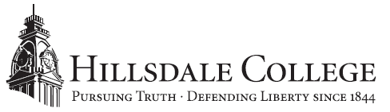

FOR IMMEDIATE RELEASE CONTACT: Emily Stack Davis
November 6, 2018 517-607-2730
PR@hillsdale.edu

Hillsdale College Alumna Named Clerk For Justice Brett Kavanaugh
2007 graduate Megan Lacy one of four clerks hired by newest Supreme Court justice
Hillsdale, Mich. – Hillsdale College congratulates alumna Megan Lacy (’07) on her new position as law clerk for Supreme Court Justice Brett Kavanaugh.

“Megan’s work both here at Hillsdale College and in her academic and professional career after graduation has been exceptional, and we’re proud to see her taking that talent and dedication to the Supreme Court,” said Nathan Schlueter, pre-law advisor at Hillsdale College. “As a clerk for Justice Kavanaugh, Megan will have an incredible opportunity to serve the American people and help defend the ideals of the Constitution, and we look forward to seeing the great work she’ll be able to accomplish in this new role.”

Lacy completed her undergraduate degree at Hillsdale College in 2007 and earned a law degree from the University of Virginia Law School in 2010. After completing her J.D., Lacy served as a law clerk for the Northern District of Texas and then joined Kirkland & Ellis LLP as a litigation associate. She later served as law clerk for the 9th District U.S. Court of Appeals before taking a role as counsel to the chairman of the federal Senate Judiciary Committee. Prior to accepting the role of clerk to Justice Kavanaugh, Lacy was senior advisor to the general counsel of the U.S. Department of the Treasury.

As a clerk to Justice Kavanaugh, Lacy will assist in preparing opinions and dissents, crafting arguments and recommending cases for hearings.

About Hillsdale College
Hillsdale College is an independent liberal arts college located in southern Michigan. Founded in 1844, the College has built a national reputation through its classical liberal arts core curriculum and its principled refusal to accept federal or state taxpayer subsidies, even indirectly in the form of student grants or loans. It also conducts an outreach effort promoting civil and religious liberty, including a free monthly speech digest, Imprimis, with a circulation of more than 3.9 million. For more information visit hillsdale.edu.

# # #

